 | Topic/Unit: |  | Name:
 |  |  | Class/Period:
 |  |  | Date:
I can…
Questions/Main Ideas:
 |  | 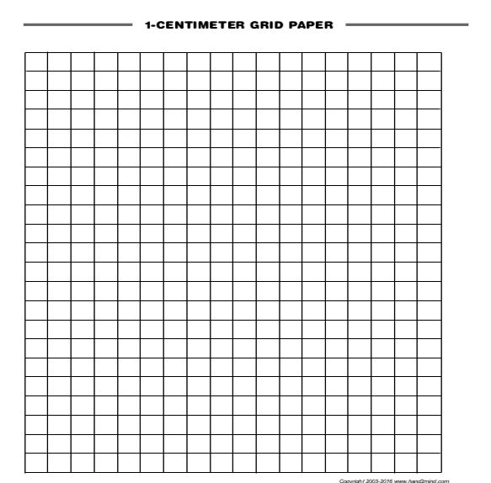

Questions/Main Ideas:
Summary/Reflection

